**Lab-4 Pre-lab**

**Section 1: Differentiator**

An OP-Amp can be used to construct an integrator or a differentiator. Figure 5 shows differentiator circuit. The output of the differentiator remains at input offset (approximately 0). However,

any sudden disturbance at the input causes it to ring at natural frequency, ω0. Below is a snapshot of transfer function of differentiator taken from Chapter 3 of TI’s ASLK Pro manual.

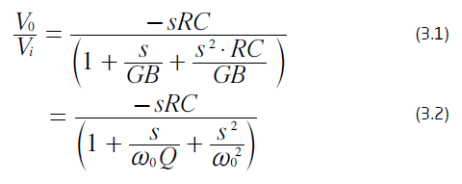

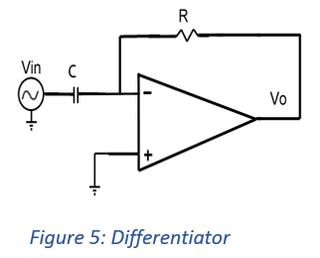

What is differentiation (dv/dt) of the following (you may draw or write them out):

1. Sine: Cosine
2. Square signal: delta function where there are spikes at the transition points
3. Ramp signal: 1, or whatever the slope is
4. What is the derivative of the delta function: doublet function

Section 2:

Go through the concepts of integrator by visiting below link

<https://www.electronics-tutorials.ws/opamp/opamp_6.html>

**Further readings/references**:

Differentiator: <https://www.electronics-notes.com/articles/analogue_circuits/operational-amplifier-op-amp/analogue-differentiator-circuit.php>